pXRF analysis

Uine Kailamäki

04/01/2021

## [1] "Type" "MgO" "Al2O3" "SiO2" "K2O" "CaO" "TiO2" "MnO" "Fe2O3"  
## [10] "ZnO" "Rb2O" "SrO" "ZrO2" "BaO"

## Rows: 13  
## Columns: 14  
## $ Type <chr> "Puumala ref", "Puumala ref", "Puumala ref", "Värikallio näyt...  
## $ MgO <dbl> 0.810, 1.302, 1.609, 0.885, 0.582, 1.140, 0.833, 0.252, 1.660...  
## $ Al2O3 <dbl> 10.240, 9.890, 12.740, 6.700, 5.750, 9.940, 12.170, 1.071, 13...  
## $ SiO2 <dbl> 77.9, 81.7, 67.0, 68.7, 85.1, 72.2, 73.7, 97.5, 73.4, 80.5, 6...  
## $ K2O <dbl> 1.1180, 2.1800, 2.0400, 0.9678, 0.3190, 2.3100, 0.6780, 0.380...  
## $ CaO <dbl> 0.753, 0.222, 0.404, 17.990, 1.133, 1.820, 0.825, 0.242, 2.49...  
## $ TiO2 <dbl> 1.3220, 0.5201, 0.1140, 0.0990, 0.0607, 0.0648, 0.1150, 0.000...  
## $ MnO <dbl> 0.0230, 0.0000, 0.0225, 0.0052, 0.0095, 0.0211, 0.0111, 0.000...  
## $ Fe2O3 <dbl> 4.2500, 3.1500, 7.4900, 1.7000, 1.6000, 2.0200, 1.9700, 0.059...  
## $ ZnO <dbl> 0.0031, 0.0022, 0.0204, 0.0027, 0.0027, 0.0035, 0.0029, 0.000...  
## $ Rb2O <dbl> 0.0097, 0.0124, 0.0163, 0.0067, 0.0050, 0.0085, 0.0023, 0.000...  
## $ SrO <dbl> 0.0055, 0.0034, 0.0442, 0.0127, 0.0156, 0.0219, 0.0136, 0.000...  
## $ ZrO2 <dbl> 0.0201, 0.0426, 0.0183, 0.0142, 0.0139, 0.0210, 0.0305, 0.000...  
## $ BaO <dbl> 0.0338, 0.0711, 0.0896, 0.0000, 0.0205, 0.0588, 0.0200, 0.000...

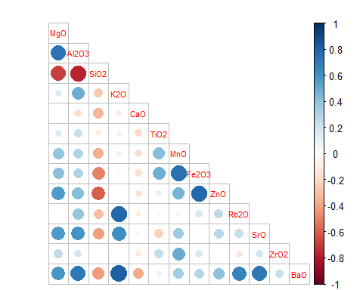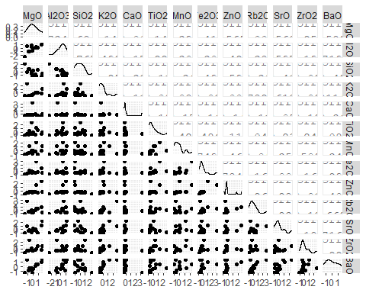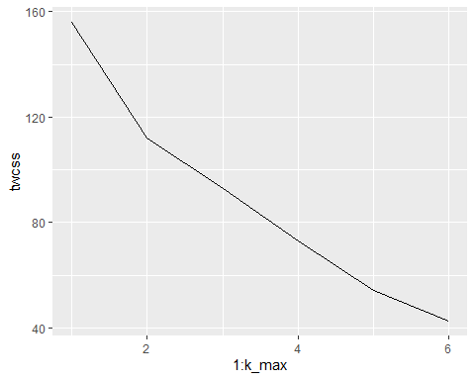

## Importance of components:  
## PC1 PC2 PC3 PC4 PC5 PC6 PC7  
## Standard deviation 2.2417 1.5561 1.2594 1.1656 0.97100 0.86724 0.67377  
## Proportion of Variance 0.3865 0.1863 0.1220 0.1045 0.07253 0.05785 0.03492  
## Cumulative Proportion 0.3865 0.5728 0.6948 0.7993 0.87185 0.92971 0.96463  
## PC8 PC9 PC10 PC11 PC12 PC13  
## Standard deviation 0.50589 0.40585 0.16605 0.08596 0.06492 3.72e-17  
## Proportion of Variance 0.01969 0.01267 0.00212 0.00057 0.00032 0.00e+00  
## Cumulative Proportion 0.98432 0.99699 0.99911 0.99968 1.00000 1.00e+00

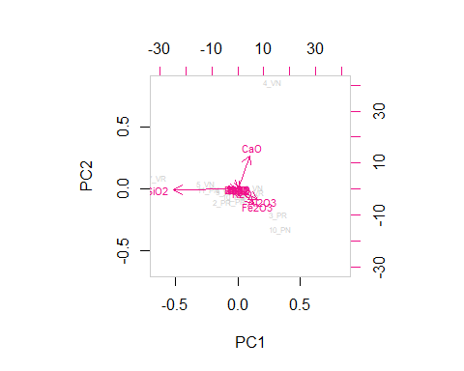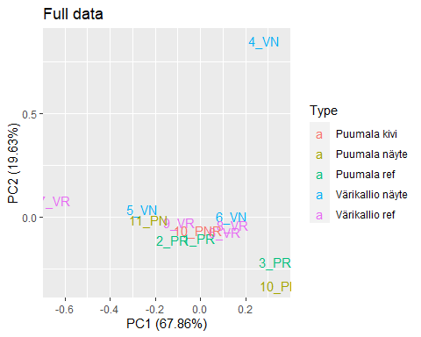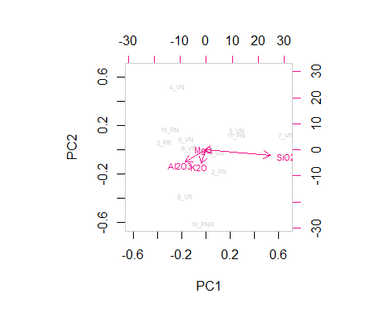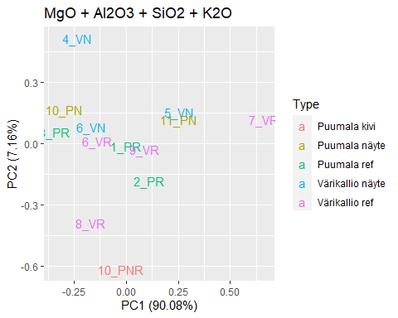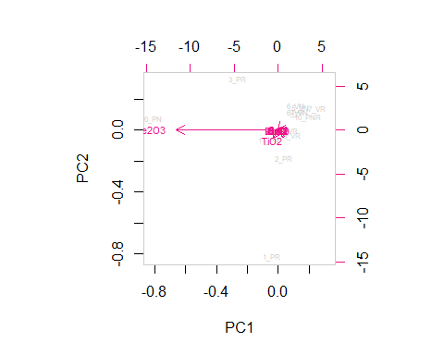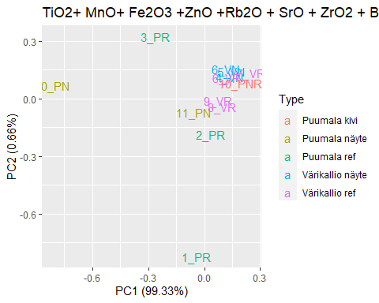

## [1] 0.5400877

